Activist Art
Student’s Name
Institutional Affiliation

Activist Art
Pandemic preparedness is crucial in American households based on the challenges being faced currently with regards to the covid-19. The coronavirus came unawares, and many people have been caught off-guard. Not only the American households were unprepared, but the government also had not planned adequately for the Covid-19 pandemic. In this regard, the pandemic has taken a toll on the people as well as the government. From a financial standpoint, most people did not have financial backings to sustain them during the pandemic. Thus, people are more exposed when going about their day-to-day activities, trying to fend for their families. Besides, most families have been forced to cut down their budgets in a bid to counter the adverse financial impacts associated with the pandemic. Most people have also become sensitive about how they use their income since they are uncertain about the future. The issues mentioned above depict how unprepared most families were.
Moreover, the American government had no mechanisms in place to counter the effects of the coronavirus pandemic. The U. S government did not have enough respiratory devices that would be used in such an emergency (Jacobs & Fink, 2020). Also, they did not have frameworks of how to determine persons that should get medical interventions in case the existing hospitals are over flooded. The United States did not also move fast enough to contain the virus when the first case was reported in January. The authorities now have to struggle to trace and isolated suspected victims when the number of cases has risen to alarming levels. Statistical evidence shows that 55 % of Americans are opined that the American government was not prepared for the pandemic (Haltiwanger, 2020). As a result, the country has reported approximately 1.16million cases of coronavirus up to now. President Trump has also been under intense criticism for downplaying the risk of the deadly virus. In the end, the U.S government was only to put restrictions on the people in a bid to contain the spread of the virus.
Therefore, there is a need to raise awareness on the issue of pandemic preparedness since it will make people and the government be more prepared for emergencies. For instance, the government will have mechanisms in place to curb such pandemics immediately after the warning alarms are sounded. The government will not have to wait until the situation gets worse to initiate countermeasures. Awareness will also ensure that the government sets asides adequate funds and resources to fight another outbreak like the coronavirus one. As a result, the government will not be shorthanded in terms of expertise, money, and health resources, resulting in maximum health outcomes. Creating extensive awareness will also ensure that households have strategies in place to counter the effects of another pandemic. For example, many individuals will start saving for such circumstances to ensure that they are not strained in the future. In the end, people will be able to sustain themselves as well as their families during the pandemic period.
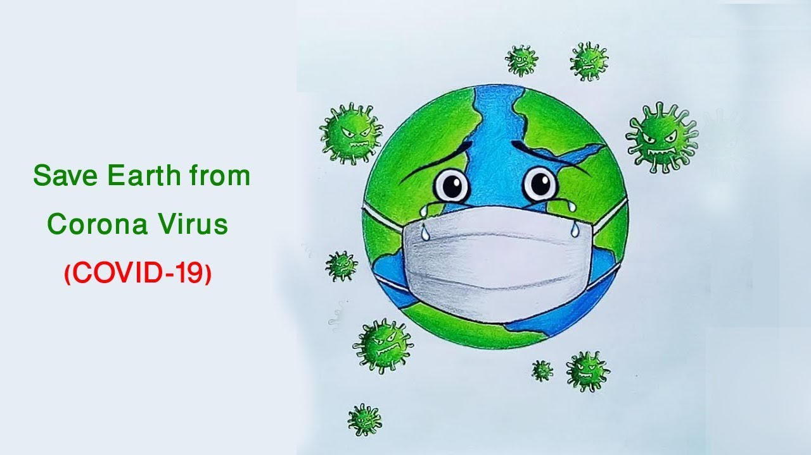
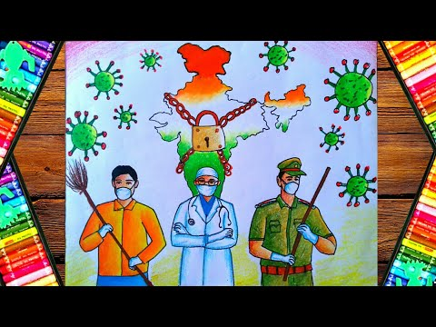
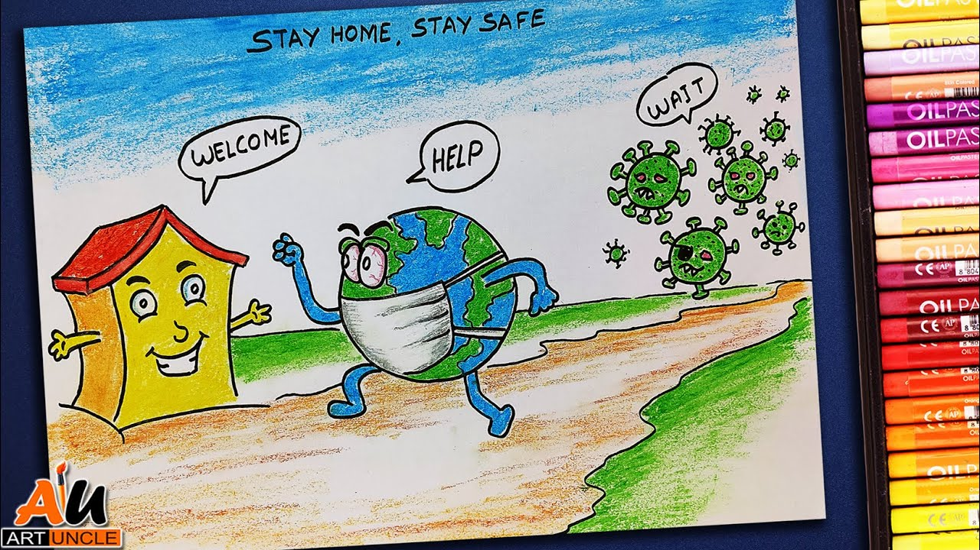
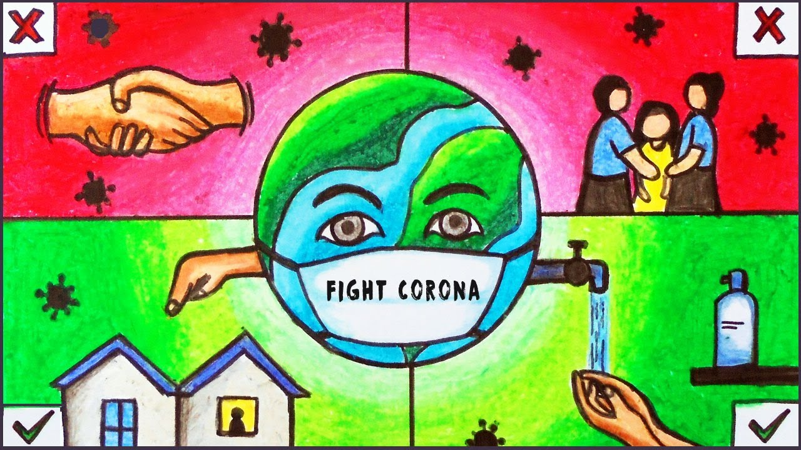
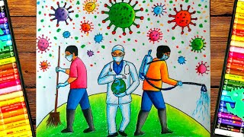
The tile should be installed in billboards in city areas as well as metropolitans on highways where people can view it when they are on their vehicles. Most persons use highways, and this will be an effective way to ensure that the maximum number of people see the art. Lawmakers also use these highways, and it would be more effective as compared to subways or railway terminuses. Besides, billboards are also very large, and they will be able to display this activist artwork even when the view is not so close to them.

References
Haltiwanger, J. (2020). 55% of Americans now say the US government was not prepared for
coronavirus. Business Insider. Retrieved from
https://www.pulselive.co.ke/bi/politics/55-of-americans-now-say-the-us-government-was-not-prepared-for-coronavirus/z0c3cxk
Jacobs, A. & Fink, S. (2020). How prepared is the U.S for a coronavirus outbreak? The New
York Times. Retrieved from https://www.nytimes.com/2020/02/29/health/coronavirus-preparation-united-states.html

